Starting a Story Worksheet

|  |  |
| --- | --- |
| Call to Action | 1. Target low socio-economic areas by providing more funding into food programs and improving economic wellbeing through investments to increase access to food and sustain food systems; and |
| Why | The government fears not enough people have access to food, creating food security concerns caused by a range of social and economic factors.  Need to ensure there is economic support for food supply to meet food demand to keep prices stable. Fears demand exceeds the supply causing food security concerns and panic in the public.  Need to distribute food equally to ensure people have access to food.  End world hunger and ensure access by all people, the poor and people in vulnerable situations, to safe, nutritious, and sufficient food all year round  To promote agriculture production that better nourishes Americans while also helping feed others throughout the world |
| Setting | Defining food security, measurement, and background  49 million people turning to food assistance.  44 million people food insecure.  Introduce the economic impacts of Covid-19 pandemic  Introduce the socio-economic inequalities rooted in society |
| Characters | Government  US Department of Agriculture (USDA)  US Environmental Protection Agency (EPA)  Food and Drug Administration (FDA)  Note: these three organisations are connected as part of the ***Federal Interagency Collaboration*** to reduce food loss, waste, and food insecurity. |
| Conflict | Government Budget constraints  Managing the economic environment  Widening wealth and socio-economic gap |
| Plot | Notes:   * ***Presentation*** * **First Section**: Looking at trends in food security, why is it a concern now? Why is it important now? * Connections and motivation with previous macro-economic event, the GFC (Global Financial Crisis) * Motivation: with the GFC, food insecurity persisted for a longer time frame, how can we taper it down faster in the post Covid-19 pandemic * **Second Section**: Description of pandemic economic instability on food insecurity (e.g. inflation, unemployment, economic activity, food markets) * Analysis of why this is happening? 🡪 economic instability…. * **Third Section**: Description of Socio-Economic impacts (e.g. race, ethnicity) on food insecurity * Analysis of why this is happening? 🡪 Wealth, financial stress, poverty, economic development |

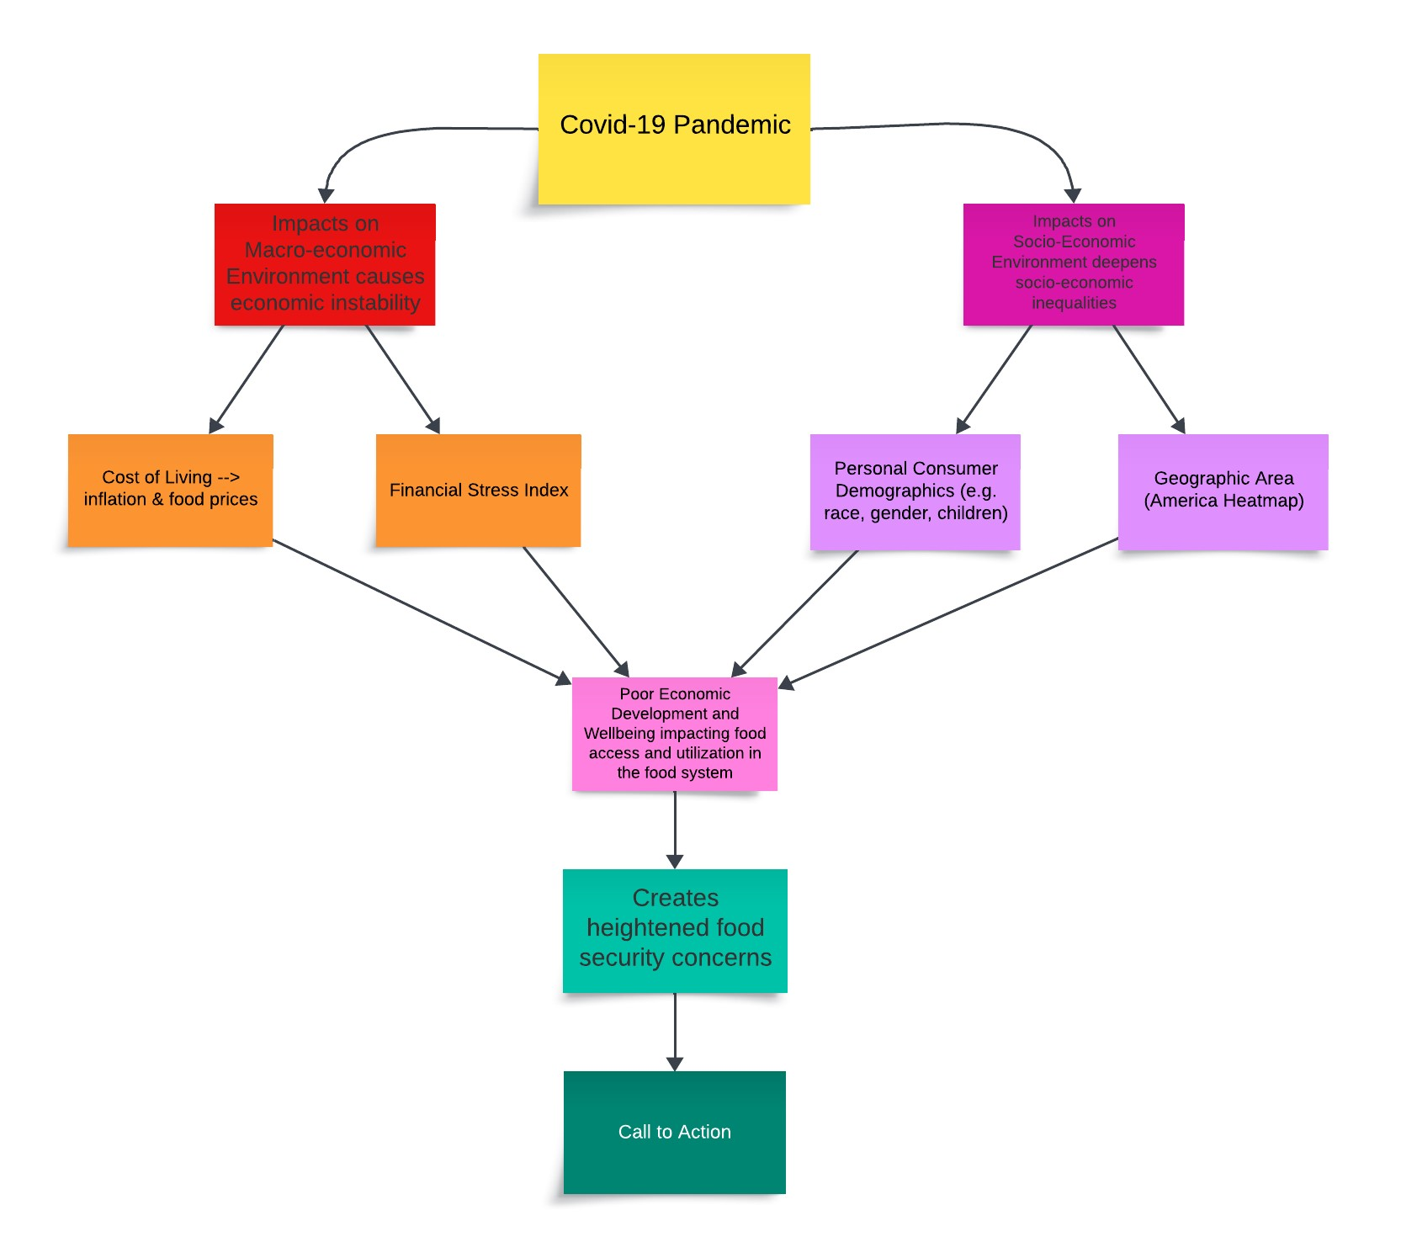

Graphs to Include in Presentation:

1. First Section

* Overall trend in food security 🡪 comparing to the GFC
* Try to obtain USDA food and nutrition assistance expenditure data 🡪 show trends using stacked area chart

1. Second section

* Trends in Macro environment 🡪 inflation & financial stress index
* Relationship between food scarcity (HH pulse survey) and macroeconomic variables (scatter plot relationship)

1. Third Section

* Consumer demographics on food insecurity
* 🡪 ethnicity 🡪 bar graph or stacked area chart
* 🡪 household composition 🡪 bar graph
* 🡪 income to poverty ratio 🡪 boxplots, distributions, stacked area chart?
* Food insecurity geographic region (use a heatmap of America)
* Access to food hubs and assistance programs
* Income expenditure on food (different income levels) 🡪 [optional] look at relationship between income expenditure on food and food insecurity (scatter plot)